Demo
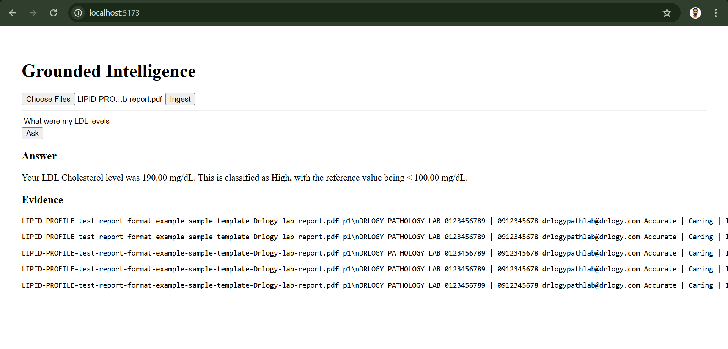
The "Truth" Script and Demo
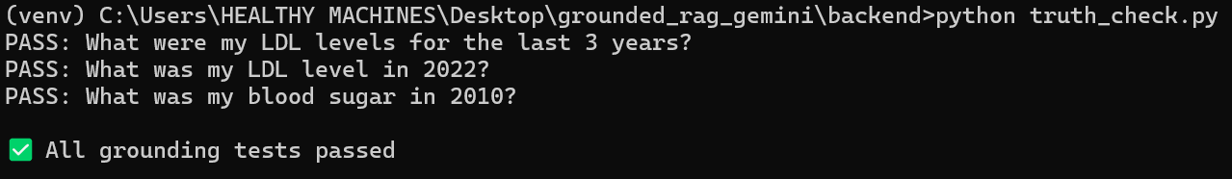
Architecture Decision Summary
The system is retrieval-first, evidence-driven, and explicitly refuses to answer when the documents do not support a claim.

1. Chunking Strategy
I chose page-aware, overlapping text chunking.
- Each chunk is associated with:
  - Source PDF
  - Page number
- Chunk size is intentionally small with overlap to:
  - Reduce hallucinations
  - Preserve local context
  - Enable precise citation
This makes it possible to show exact evidence for every answer, which is essential in clinical workflows.

2. OCR Strategy
The ingestion pipeline:
- Automatically detects whether a PDF contains extractable text
- Falls back to OCR for scanned or image-based PDFs
This mirrors real-world patient uploads (photos, scans, faxes).

3. Vector Store Choice
I chose FAISS (local, in-memory) for the POC because:
- Fast and transparent
- Easy to debug and inspect
- No operational overhead for a 48-hour challenge
The design allows easy migration to a managed vector database later.

4. Embedding Strategy
To avoid quota and latency issues:
- Local embeddings (SentenceTransformers) are used for retrieval
- Gemini 2.5 Flash is used only for reasoning and answer synthesis
This decoupling reflects how many production RAG systems are built.

5. Hallucination Prevention
Hallucinations are prevented by design:
- The LLM receives only retrieved chunks
- No fallback to model memory
- Explicit refusal when evidence is missing

